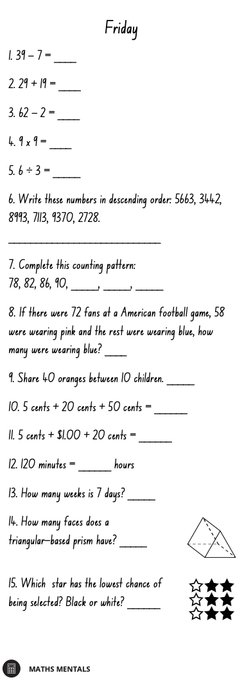
Multiplication Spirals
- Choose 5 spirals and use a timer to time yourself.
- Write your time above each spiral each day and try to beat that time the following day.
- You should choose the times table you are the least confident with to improve.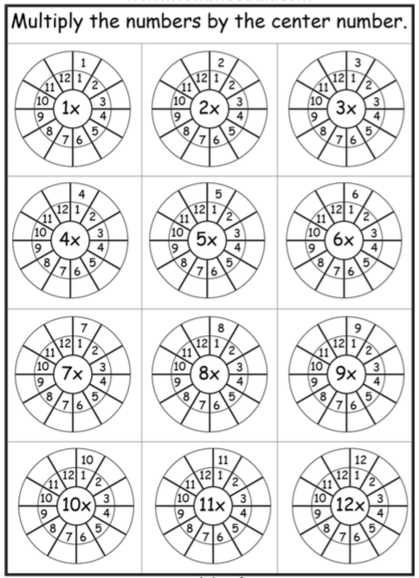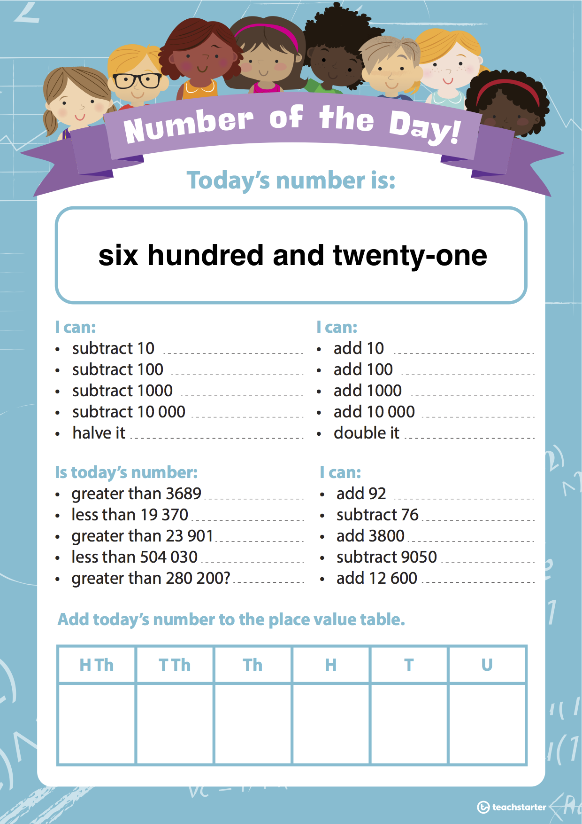
Displacement experiment
WALT: Recognise that displacement is an increase in the level of water in a container due to an object being submerged within the container

You will need:
- Clear container - Water - 3 rocks - Marker or tape

Investigation:
Complete the following experiment outside with adult supervision. Answer the questions as you go.

- Fill a clear container to the top with water.
- Find 3 rocks of different sizes in your backyard. Tie a piece of string to each one to allow it to be removed without affecting the level of water.
- Place 1 rock in the container and watch the water overflow.

Why do you think the water overflows?
_______________________________________________________________________________
_______________________________________________________________________________

Can you think of any situations in life where a similar thing happens?
_______________________________________________________________________________
_______________________________________________________________________________

This is called displacement.

Displacement: How much liquid is pushed away when an object is placed in it.
The volume of the object placed in the water is equal to the amount of liquid that is displaced.

- Remove the rock and fill the water to the top of the container.
- Place one rock in the water, let it overflow, remove the rock and mark the height of the water in the container with a marker or piece of tape.
- Fill the water to the top of the container and repeat using the second and third rock.
- Order the rocks according to how much water they ‘shift’ or ‘push up’ when placed in the container.

Why do you think the water overflows more for one object but less for another?
_______________________________________________________________________________
_______________________________________________________________________________

Optional: Find 3 other objects of different sizes that can be submerged in water and test to see if they displace more or less water than the rock. Record your findings.

