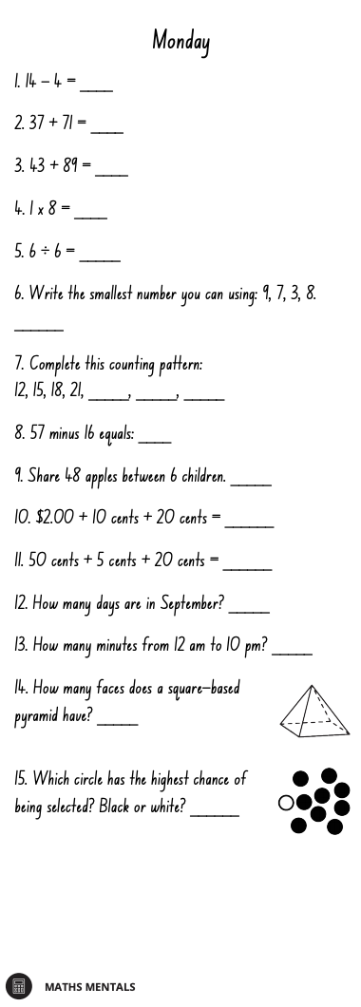
Multiplication Spirals
- Choose 5 spirals and use a timer to time yourself.
- Write your time above each spiral each day and try to beat that time the following day.
- You should choose the times table you are the least confident with to improve.

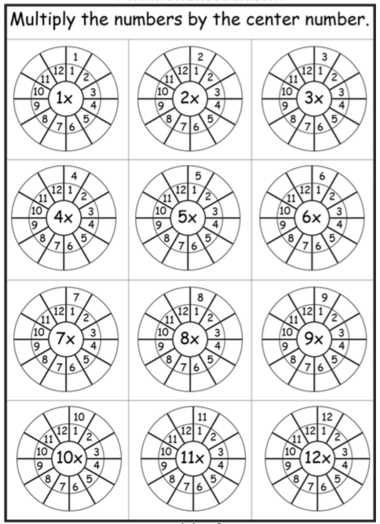

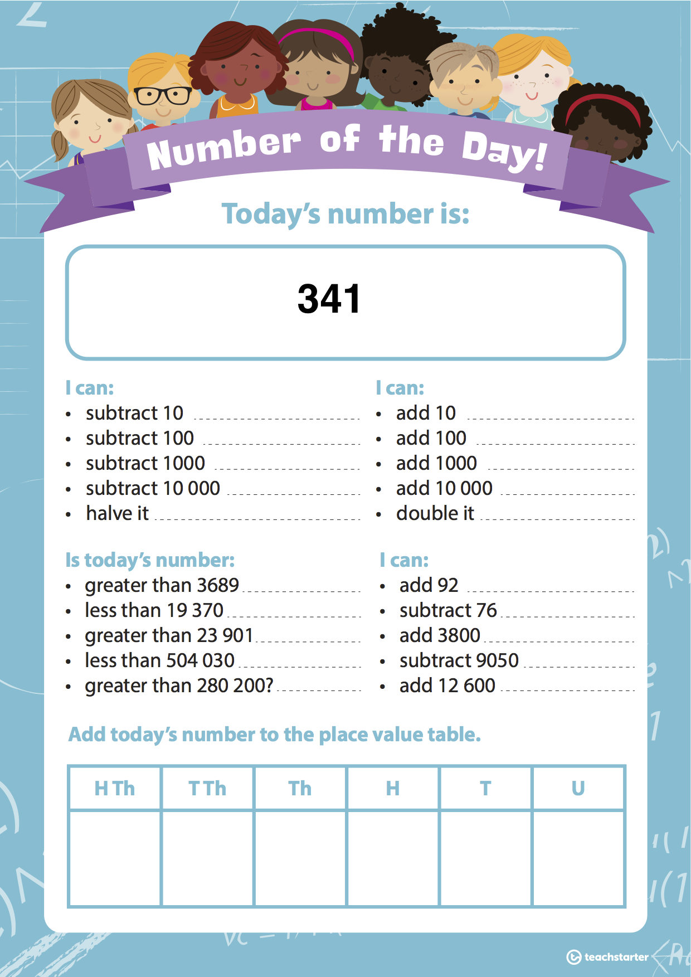
WALT: Follow rules to extend number patterns and predict future terms in the patterns.
Example:

Rule: Add 3

The 7th term would be the 6th term plus 3. 18 + 3 = 21
The 8th term would be the 7th term plus 3. 21 + 3 = 24

Activity 1: Find the rule to extend these patterns and predict the future term.
1. 0, 6, 12, 18, __, __, __, What would be the eighth term? ___
2. 30, 40, 50, 60, __, __, __ What would be the ninth term? ___
3. 24, 28, 32, 36, __, __, __ What would be the ninth term? ___
4. 16, 21, 26, 31, __, __, __ What would be the tenth term? ___
5. 44, 48, 52, 56, __, __, __ What would be the tenth term? ___
6. 36, 33, 30, 27, __, __, __ What would be the twelfth term? ___
7. 40, 95, 150, 205, __, __, __ What would be the tenth term? ___
8. 123, 148, 173, 198, __, __, __ What would be the ninth term? ___
9. 306, 266, 226, 186, __, __, __ What would be the eighth term? ___
10. 105, 96, 87, 78, __, __, __ What would be the tenth term? ___
Activity 2: Follow the 2-step rules to complete the number patterns.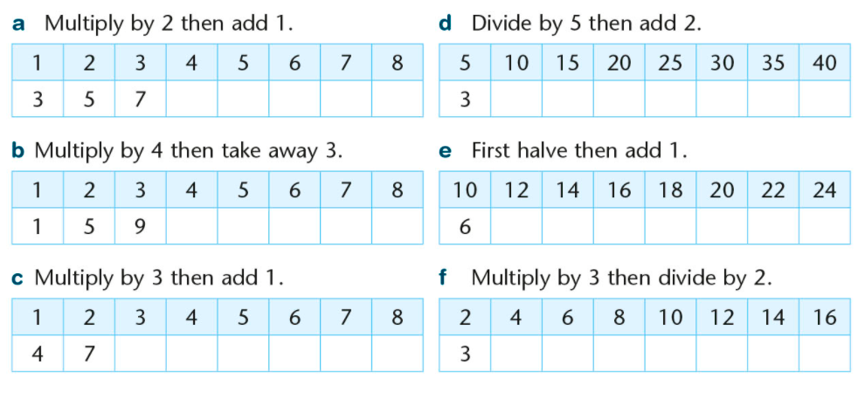
Create your own number pattern that uses a 2-step rule. Have a friend complete the number pattern to the tenth term.

