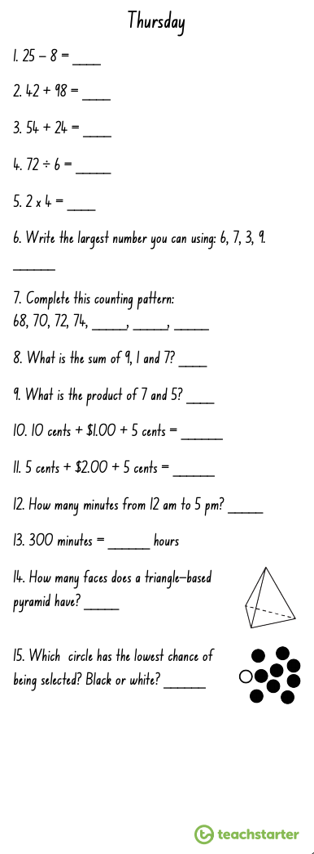
Multiplication Spirals
- Choose 5 spirals and use a timer to time yourself.
- Write your time above each spiral each day and try to beat that time the following day.
- You should choose the times table you are the least confident with to improve.

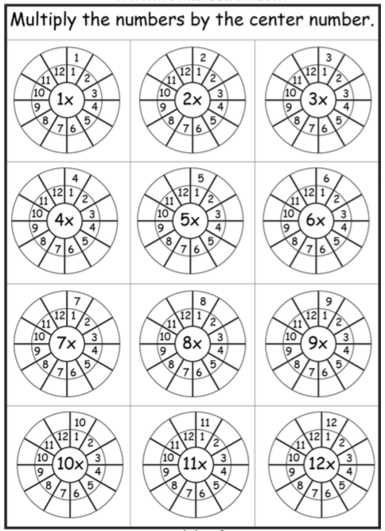

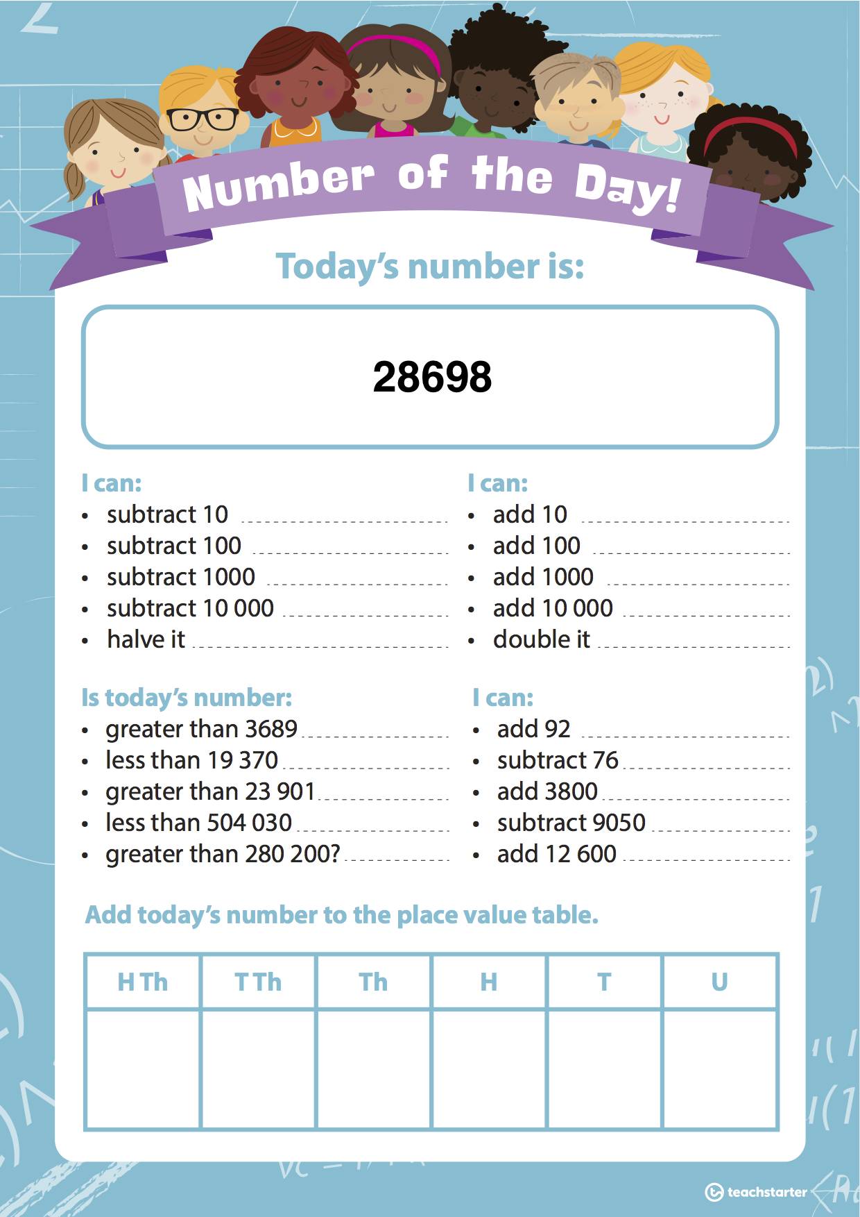

WALT: Show how capacity can be recorded in millilitres as well as litres and millilitres.

1 Litre (L) = 1000 millilitres (mL)

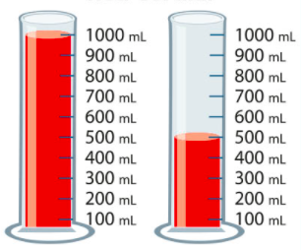
Example: If one cup contains 1000 mL of water and another cup contains 500 mL of water, how much water do they contain altogether?

Step 1: Solve the problem.
1000 mL + 500 mL = 1500 mL

Step 2: Convert to litres and millilitres.
1500 mL = 1000 L and 500 mL

Activity 1: Complete the following questions and convert millilitres into litres and millilitres.

- If one cup contains 1000 mL of water and another cup contains 700 mL of water, how much water do they contain altogether?
___ millilitres OR ___ litre ___ millilitres
- If one cup contains 1000 mL of water and another beaker cup 400 mL of water, how much water do they contain altogether?
___ millilitres OR ___ litre ___ millilitres
- If one cup contains 1200 mL of water and another cup contains 300 mL of water, how much water do they contain altogether?
___ millilitres OR ___ litre ___ millilitres
- If one cup contains 1500 mL of water and another cup contains 200 mL of water, how much water do they contain altogether?
___ millilitres OR ___ litre ___ millilitres
- If one cup contains 1100 mL of water and another cup contains 800 mL of water, how much water do they contain altogether?
___ millilitres OR ___ litre ___ millilitres
- If one cup contains 900 mL of water and another cup contains 700 mL of water, how much water do they contain altogether?
___ millilitres OR ___ litre ___ millilitres
- If one cup contains 1250 mL of water and another cup contains 250 mL of water, how much water do they contain altogether?
___ millilitres OR ___ litre ___ millilitres
- If one cup contains 750 mL of water and another cup contains 450 mL of water, how much water do they contain altogether?
___ millilitres OR ___ litre ___ millilitres
- If one cup contains 1700 mL of water and another cup contains 500 mL of water, how much water do they contain altogether?
___ millilitres OR ___ litre ___ millilitres
- If one cup contains 1450 mL of water and another cup contains 800 mL of water, how much water do they contain altogether?
___ millilitres OR ___ litre ___ millilitres

Activity 2: Calculate how many more millilitres are needed to make a litre.

