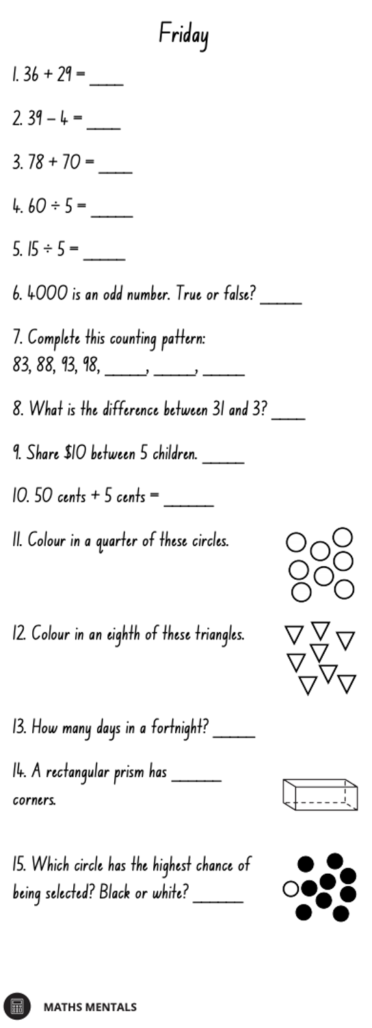
Multiplication Spirals
- Choose 5 spirals and use a timer to time yourself.
- Write your time above each spiral each day and try to beat that time the following day.
- You should choose the times table you are the least confident with to improve.

