Monday - Maths - Week 1 - Year 3

WALT: Identify and describe rules for number patterns.

Teaching Tips: Continue a pattern of 8 numbers and predict the 10th term.
Complete patterns using fractions, e.g.
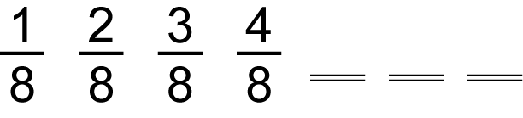
________________________________________________________________________________________

Activity 1: Complete the pattern up to eight numbers, then state what the tenth number would be.
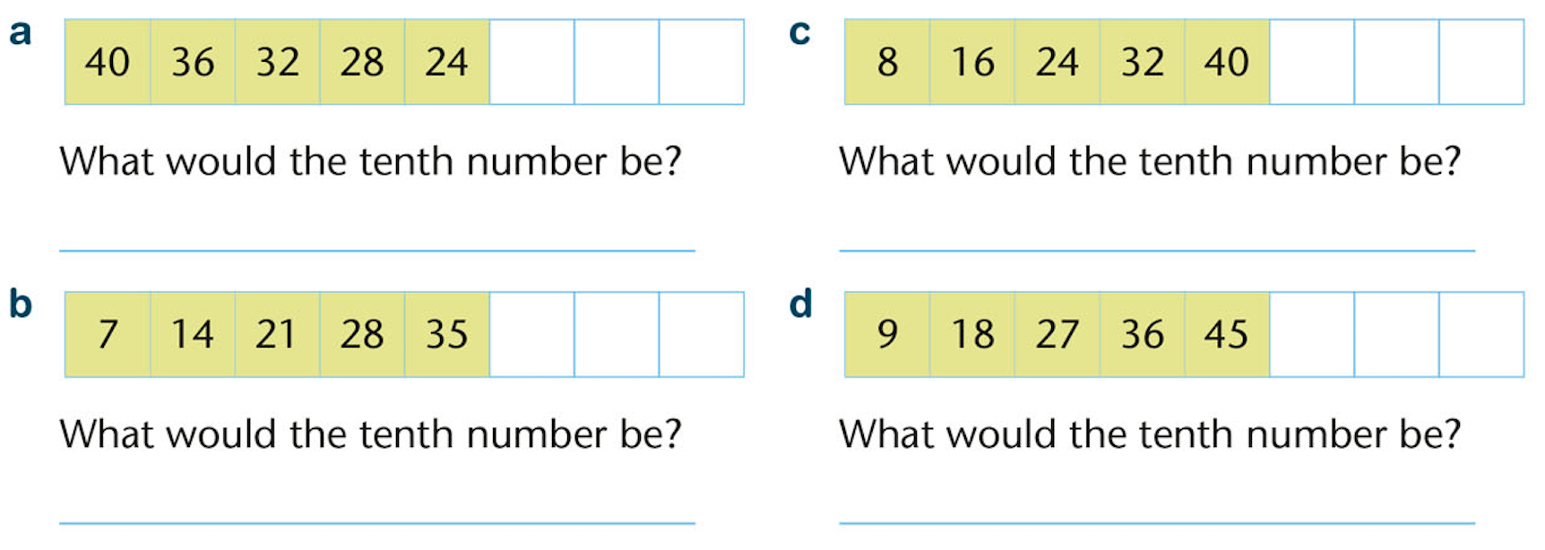
________________________________________________________________________________________

Activity 2: Complete the fraction patterns.
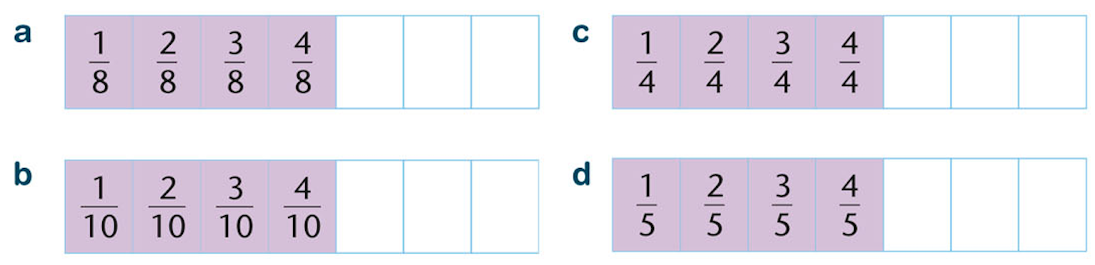
________________________________________________________________________________________

Activity 3: Add 6 to this group of numbers.
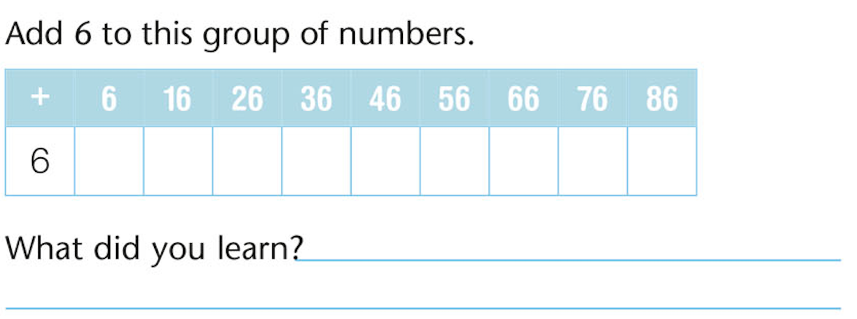
Activity 4: Make up a number pattern that adds to 7 to a sequence of numbers.

