Tuesday - Maths - Week 2 - Year 3

WALT: Record and Compare objects using familiar metric units of volume.

Activity 1: Find a small box, such as a sultana packet or small chalk box, and fill it with cubic centimetre blocks or the same size. What is the volume of the box?

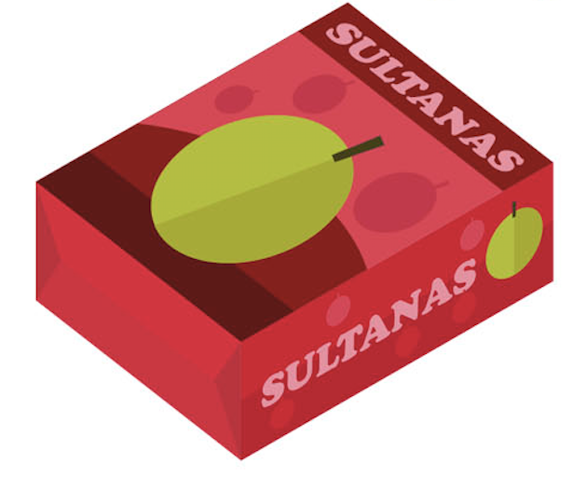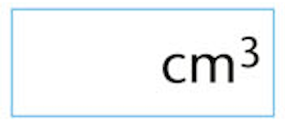

Activity 2: Make these models of centicubes if you are at school or use the pictures to work out the volume by counting the cubes used in their construction. Remember it is a 3 Dimensional shape.

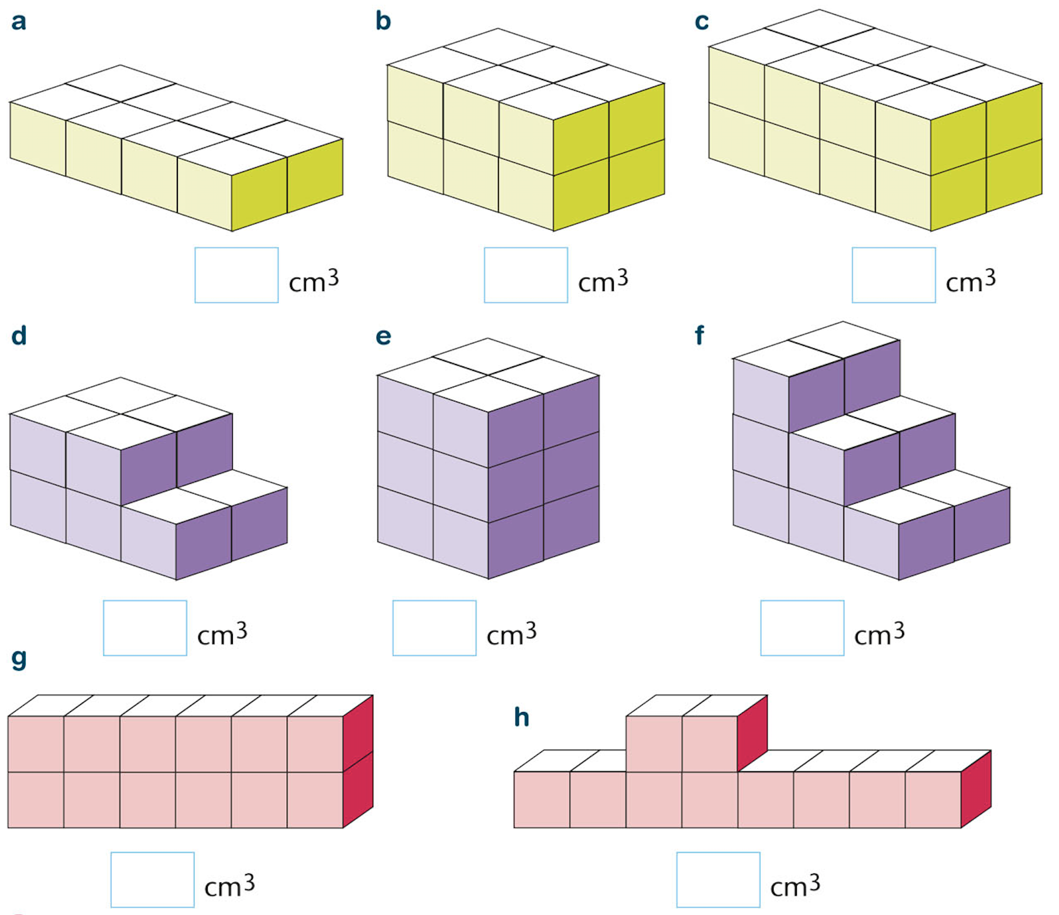

Activity 3: Use the above volumes to answer the following questions.

- Which model has the smallest volume?

- Which model has the largest volume?

- Which four models have the same volume?

