WALT: Solve word problems by selecting the appropriate mental and written strategies.

Teaching Tips:
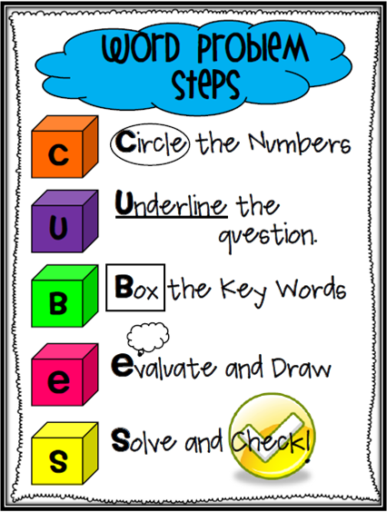

1) Find the difference between 128 and 79

2) I swam for 50 minutes and had a break. I wanted to swim for 1 hour 30 minutes. How much longer did I have to swim for?

3) Two buses seat 125 people. 38 people got off from both buses. How many people were left on the buses?

4) I have a number in my head. When I add 24 to my number it equals 93. What is my number?

5) Kate is making a cake and has 1236g of flour. She needs 2255g for the recipe. How much more flour does she need?

Extension question: This question may require more than one-step to find the answer. They might need addition and subtraction sums.

7) There are 130 books on the top shelf. I remove 65 of the books at break time. I add 19 books at lunchtime. At home I take 5 books. How many books are left on the shelf?

