Multiplication Spirals
- Choose 5 spirals and use a timer to time yourself.
- Write your time above each spiral each day and try to beat that time the following day.
- You should choose the times table you are the least confident with to improve.
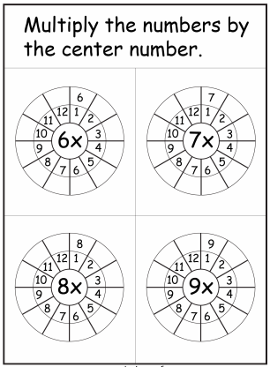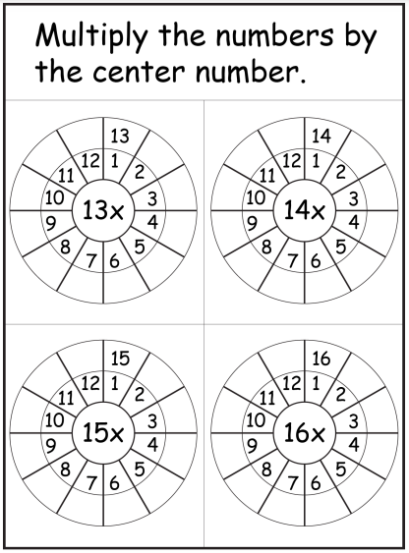

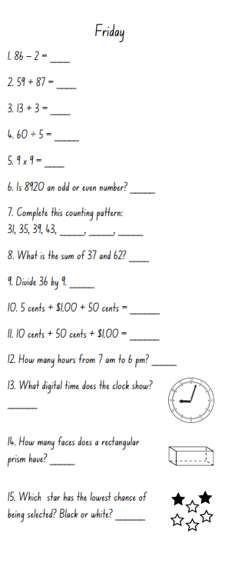

Length Investigation
WALT: Measure the length of objects and express the length in decimal notation

You will need:
- Tape measure or metre ruler
- Pencil and paper

Decimal notation:
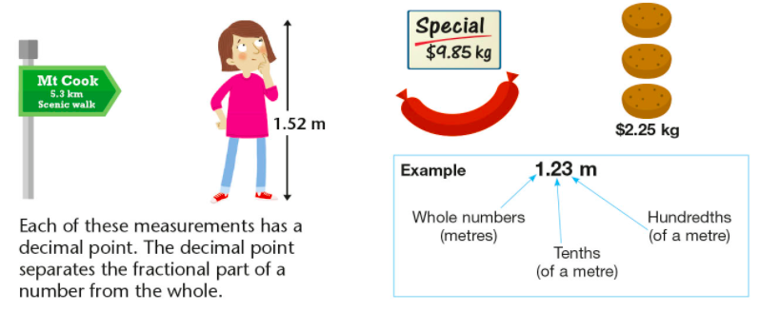
Example:
1 metre and 83 centimetres = 1.83 metres

Investigation:
Find 5 items in your house/classroom that are longer than 1 metre. Use a measuring tape or ruler, find the length of each item.

Fill out the table below.
Item | Centimetres | Metres and Centimetres | Decimal

Answer the following questions:
- Order the length of each item from smallest to largest.
- What is the difference between the smallest and the largest length?
- Add together the length of every item? What is the total?
- Take the longest item and find twice its length.
- Take the longest item and find half its length.
- Take the longest item and find a quarter of its length.
- What is the average of all 5 items? (Add all lengths together and divide by the number of items)

