Spelling Activities Week 3- Year 4

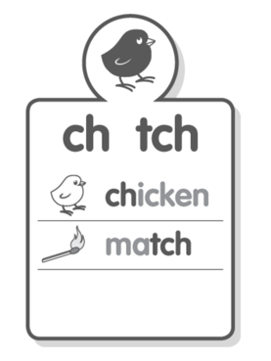
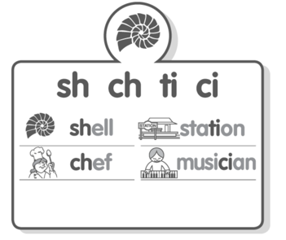
Sound Focus

www.soundwaveskids. com.au

Student Access Code: toss288
Fast finishers: play the online games

Friday:
- Complete the look-cover-write-check for Friday.
- Optional:
