WALT: Recognise that temperature is measured in degrees Celsius and identify the temperature on a thermometer.

Example: In Australia we measure temperature in degrees celsius °C
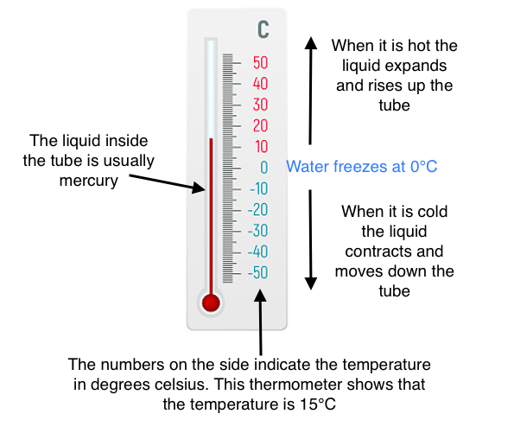

Activity 1: Research today's temperature in the following cities.

- Sydney ____________
- Brisbane ____________
- Darwin ____________
- Mebourne ____________
- Hobart ____________
- Perth ____________
- Canberra ____________
- Adelaide ____________

Then create a column graph showing your findings. What city is the hottest and which city is the coldest today?

Activity 2: Write the temperature indicated on each thermometer.
