WALT: Solve 5-digit addition using a formal written algorithm involving trading.

Example:
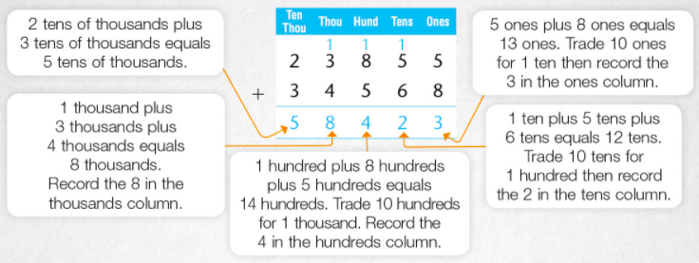

Activity 1: Complete the following addition problems involving trading. Show your working out.
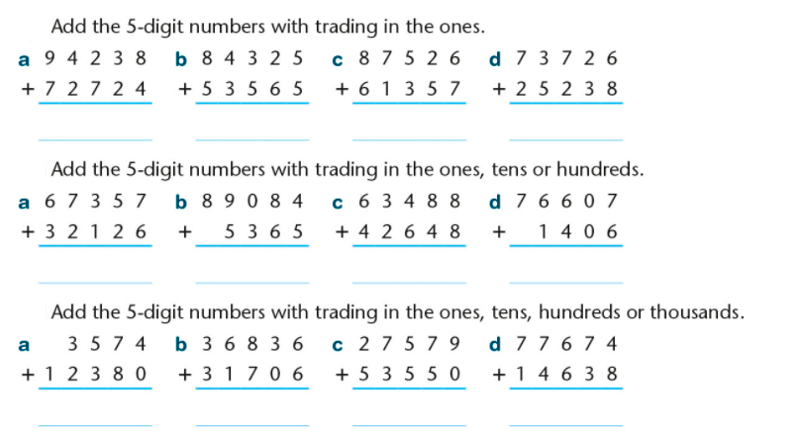

Activity 2:
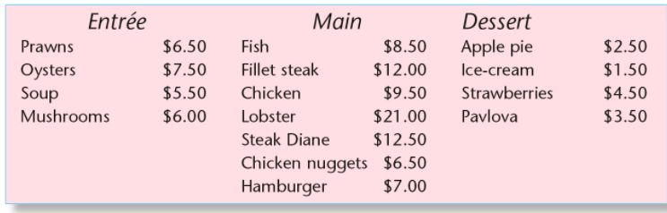
Use the restaurant menu to solve the following questions.
How much did each person or group of people spend?

- Mr Li had prawns for entree, fish for main and apple pie for dessert. _____________
- John had soup for entree, chicken for main and ice cream for dessert. _____________
- Mary had oysters, steak diane and pavlova. _____________
- Sarah had mushrooms, hamburger and strawberries. _____________
- Kyle and Rachel had prawns and oysters for entree, fish and lobster for main and apple pie for dessert. _____________
- Freddy had soup, fillet steak and ice cream. _____________
- Lily and Harry had prawns for entree, fish and chicken for main and pavlova for dessert. _____________

