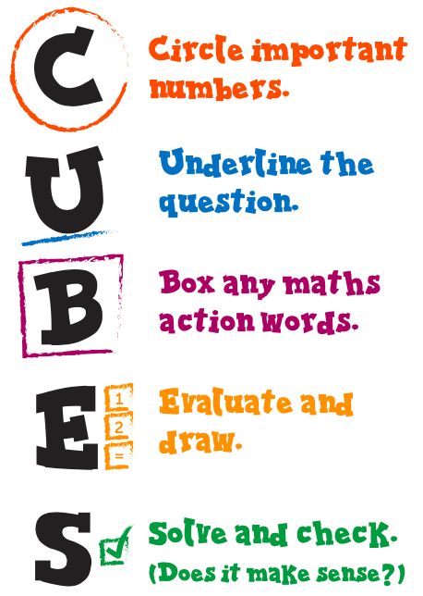
Word Problem Wednesday
WALT: Solve addition and subtraction word problems using
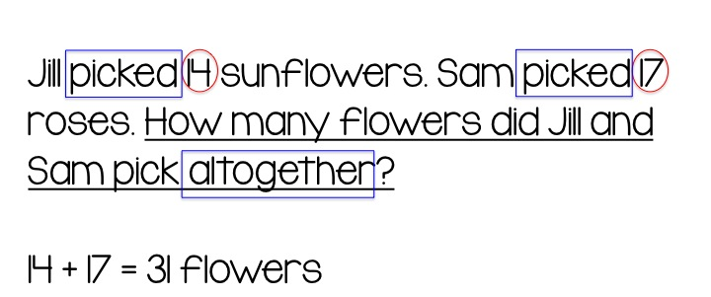
the CUBES strategy.

Activity 1: Solve the following questions using the CUBES strategy.
- Alvin bought 7 books about animals, 9 books about outer space, and 9 books about trains. Each book cost $21. How much did Alvin spend on the books?
- Max needs 91 paper plates for a birthday party. He already has 35 blue plates and 30 red plates. How many more plates should Max buy?
- 11 students and 3 teachers went on a field trip to an art museum. Student tickets cost $6 each, and adult tickets cost $11 each. How much did the museum tickets cost in all?
- Rebecca has 19 red beads, and she has 15 fewer yellow beads than red beads. Rebecca also has 2 more green beads than red beads. How many beads does Rebecca have in all?
- Troy bought 9 cartons of ice cream and 4 cartons of yoghurt. Each carton of ice cream cost $6 and each carton of yoghurt cost $2. How much more did Troy spend on ice cream than on yoghurt?
- Gavin had 16 stickers. He bought 25 stickers from a store in the mall and got 7 stickers for his birthday. Then Gavin gave 3 of the stickers to his sister and used 10 to decorate a greeting card. How many stickers does Gavin have left?
- Rachel had $10. Then she saved $8 from her allowance and spent $7 on a comic book and $3 on a puzzle. How much money does Rachel have left?
- Devin needs 49 balloons for a birthday party. He already has 3 blue balloons and 29 red balloons. How many more balloons should Devin buy?
- There are 18 students in the third grade and twice that number in the fourth grade. There are 17 boys and 19 girls in the second grade. How many students are in grades 2 through 4 altogether?
- Savannah's mum gave her $87 to go shopping. She bought a jumper for $14, a T-shirt for $13, and a pair of shoes for $13. How much money does Savannah have left?

Activity 2: Create 5 word problems of your own using the different operations (+ - x ÷). Swap with a friend and have them complete your word problems using the CUBES method.

