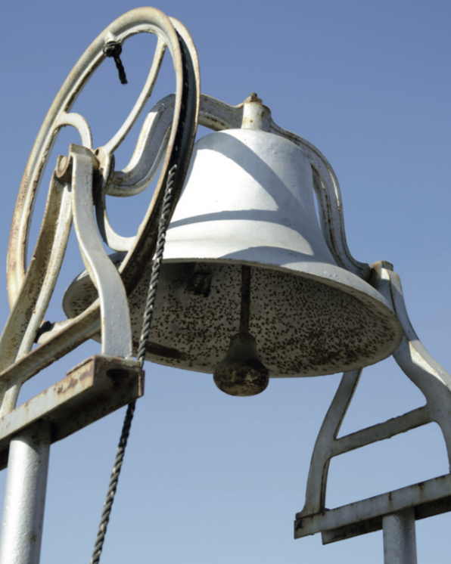
Friday - Maths - Week 2 - Year 3
WALT: Check the accuracy of my answers and explain the reasoning used.

Teaching Tips:
Make sure you read through all the information before you answer the questions.
Use your CUBE problem solving strategies to help you.

Friday Investigation - The School Bell
Mulgoa Public School is in New South Wales. Some of the buildings were built in 1883. The school started eight years before that. The school has a very old bell.
In the olden days, the bell was rung to tell the children in Mulgoa that it was time to go to school.

Activity 1:
- How old are the buildings at Mulgoa Public School?

- When was Mulgoa Public School Started?

- Who do you think rang the school bell to tell the children they should be at school?

Activity 2:
The old school bell is still used at Mulgoa Public School. The senior students ring it several times a day. Here is some information about the four times that they ring it at recess.

• At 11 o’clock the bell signals the start of eating time.
• Ten minutes later, it rings to show the start of recess playtime.
• At 27 minutes past 11, it rings to warn students that recess is nearly over.
• Three minutes after that, it rings to tell students to get into their class lines.

- How long does eating time last during recess?

- At what time do the students go out to play at recess?
- How long do the students play outside before the warning bell goes?
- At what time do students line up to go back into class?

Activity 3:
Some schools are very large. Many large schools have electronic bells. They are controlled by a small computer. The computer has a timer. The timer makes sure that the bell always goes at the correct time.

- Fraser Public School has 67 infant students and 116 primary students. How many students are in the school altogether?

- Mulgoa Public School has 110 fewer students than Fraser Public School. How many students are there at Mulgoa?

- Would you prefer a bell to be rung by the students or to be controlled by a computer? Give a reason for your answer.
- At Fraser Public School, there are three infant classes. How might the 67 students be divided between the three classes?
- How many primary classes do you think there are at Fraser Public School?

