Spelling Activities Week 2- Year 3
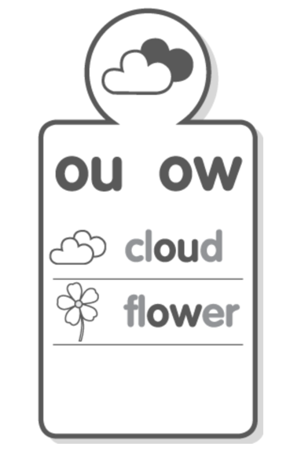
Sound Focus

www.soundwaveskids.com.au

Student Access Code: toss288
Fast finishers: play the online games

Monday:
1.Record your list words in your book.
2.Record the number of phonemes (sounds) for each word.
3.Brainstorm other words that contain the phoneme (sound).
4. Complete the look-cover-write-check for Monday.

