Thursday - Maths - Week 2 - Year 3

WALT: Use scaled instruments to measure and compare in millilitres.

Teaching Tips:
Recognise that:
- the millilitre is a unit of capacity for measuring small quantities of liquid.
- mL is short for millilitre
- 1000 mL = 1 litre.
- An example of ordering a set of containers from smallest capacity to largest -
375-mL can, 300-mL cream container, 500-mL detergent bottle.

Activity 1: Many containers have their capacity listed in milliliters. Find some containers like the ones below, then list their capacity in millilitres.
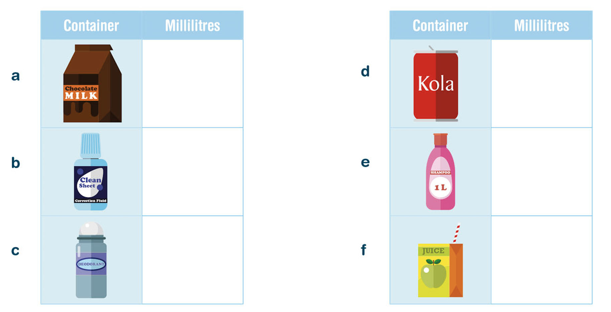

Activity 2: See if you can find a mL measuring cup such as a medicine cup. Use the measuring device to measure the capacity of four small objects around the house or classroom. For example. A cap from a water bottle.
