Spelling Activities Week 3- Year 3
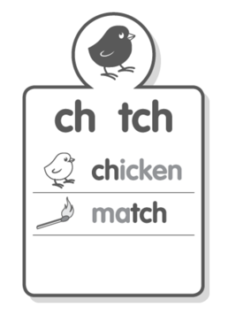
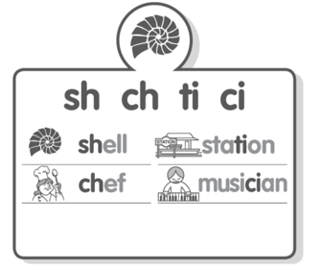
Sound Focus

www.soundwaveskids.com.au

Student Access Code: toss288
Fast finishers: play the online games

Friday:
- If possible, test yourself on your spelling words. Have someone read out your spelling list and record them.
- Optional:
