Monday - Maths - Week 3 - Year 3

WALT: Use trading when completing subtraction problems.

Teaching Tips:
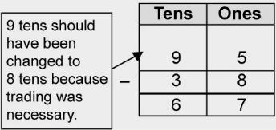

Activity 1:
Check Miss Ford’s subtractions by repeating them yourself.
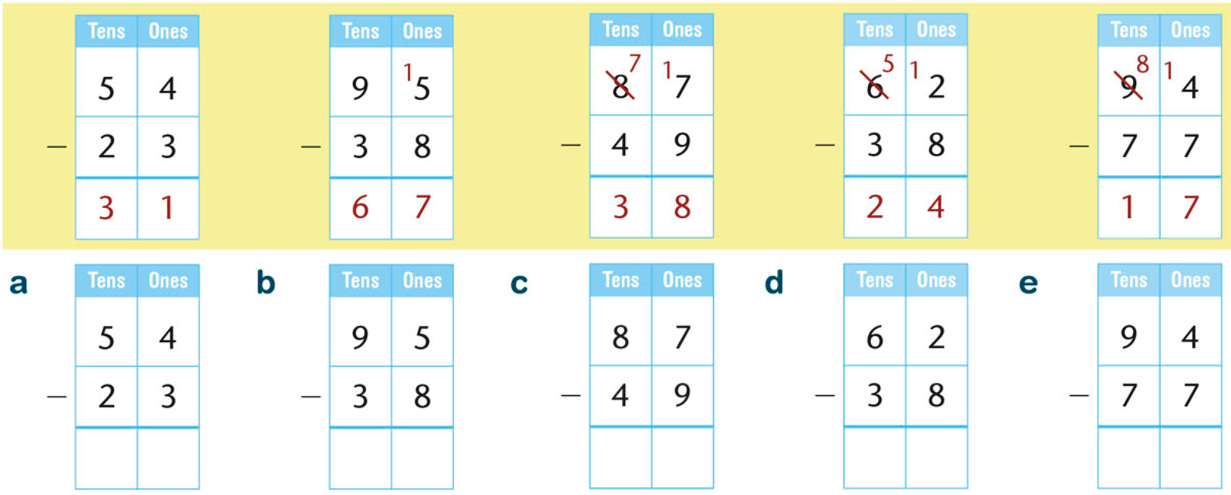

What did Miss Ford forget to do in question b?

________________________________________________________________________________

Activity 2: Use the prices below to answer the following questions.

Amelia did four calculations on her calculator and has given us her answers. Use your working out to check if your calculations are correct.

- 6 books cost $46. Correct or incorrect?

- A watch and a skateboard cost $60. Correct or incorrect?

- 7 calculators cost $105. Correct or incorrect?

- 5 watches cost $150. Correct or incorrect?

Activity 3: Max has done five subtractions. His teacher has asked him to check them by doing additions. He has done the first one. Can you do the rest?

