Thursday - Maths - Week 3 - Year 3

WALT: Estimate, measure and record length in metres and centimetres.

Teaching Tips:
- length can be measured in metres and centimetres
- 100 centimetres = 1 metre
- decimal notation can be used to record length. Eg. 1 metre 35 centimetres can be recorded as 1.35 m
- The 1 shows us there is one whole metre measured and 35cm left over (35 is smaller than 100 so we can’t make another metre)
- Estimate, measure and record length in metres and cm, e.g. The cupboard is 1 m 45 cm
- Convert measurements from metres and centimetres to metres using decimal notation, e.g. 1 m 65 cm = 1.65 m

Activity 1: Write m for metre or cm for centimetre to show which unit you would use to measure these lengths.
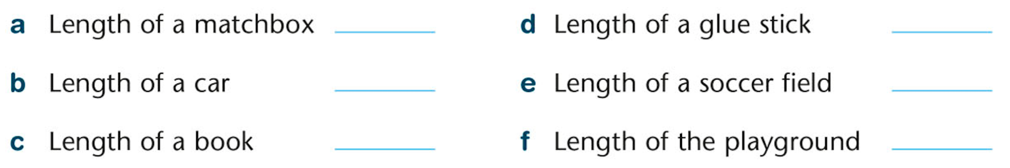

Activity 2: Convert each measurement from metres and centimetres to metres using decimal notation.
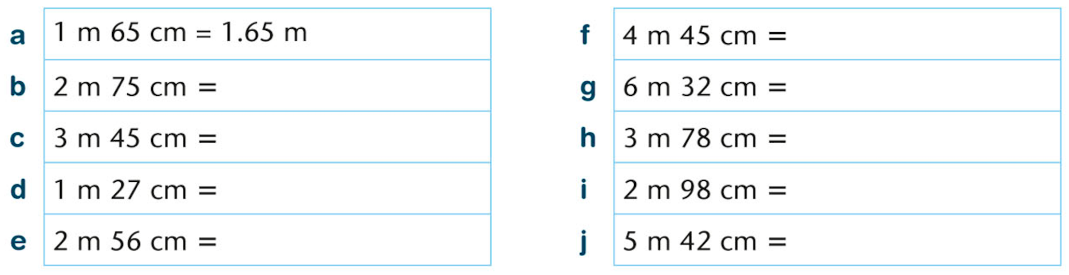

Activity 3: Draw a scaled map of your dream school playground using the following scale. Label your dream school playground measurements.

Scale 1cm = 1m

