Spelling Activities Week 3- Year 3
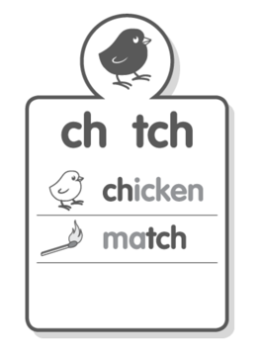
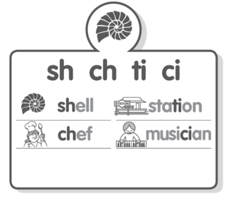
Sound Focus

www.soundwaveskids.com.au

Student Access Code: toss288
Fast finishers: play the online games

Tuesday:
- Complete the look-cover-write-check for Tuesday.
2.
