Tuesday - Maths - Week 3 - Year 3

WALT: Use trading to solve addition.

Teaching Tips:
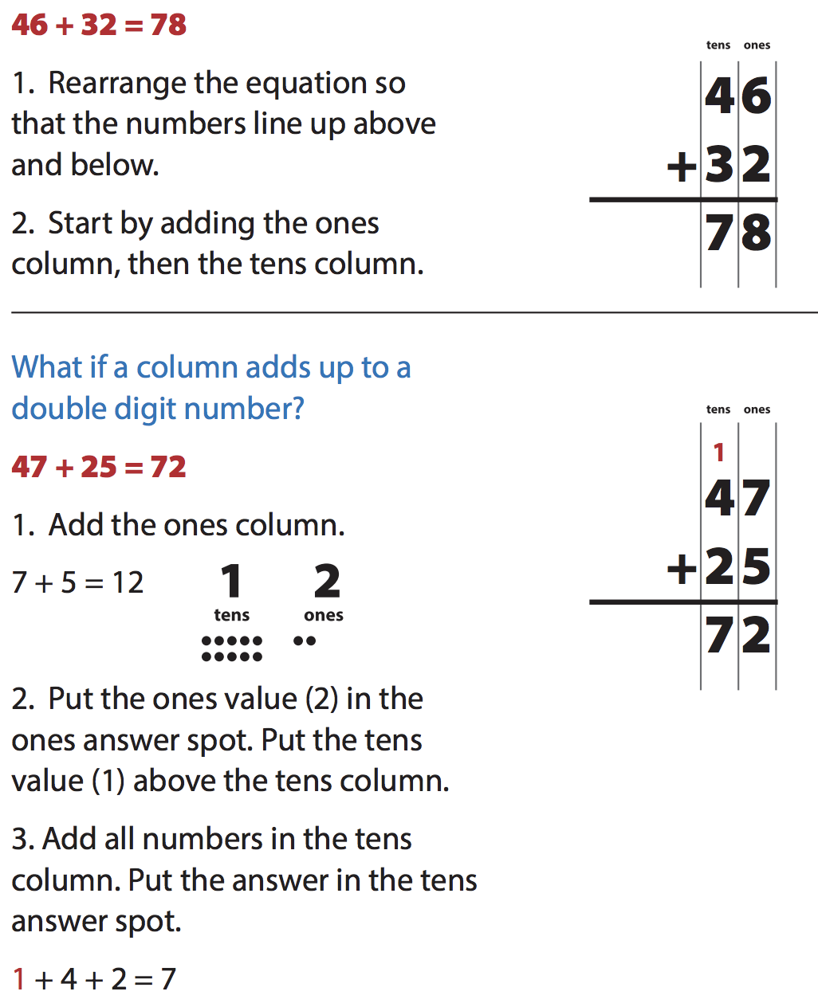

Activity 1: Complete these additions with trading in the tens. The first one is done for you.

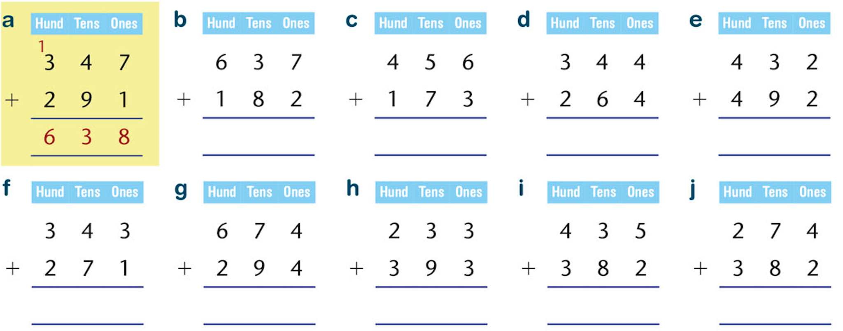

Activity 2: Complete these additions with trading in the tens and ones.

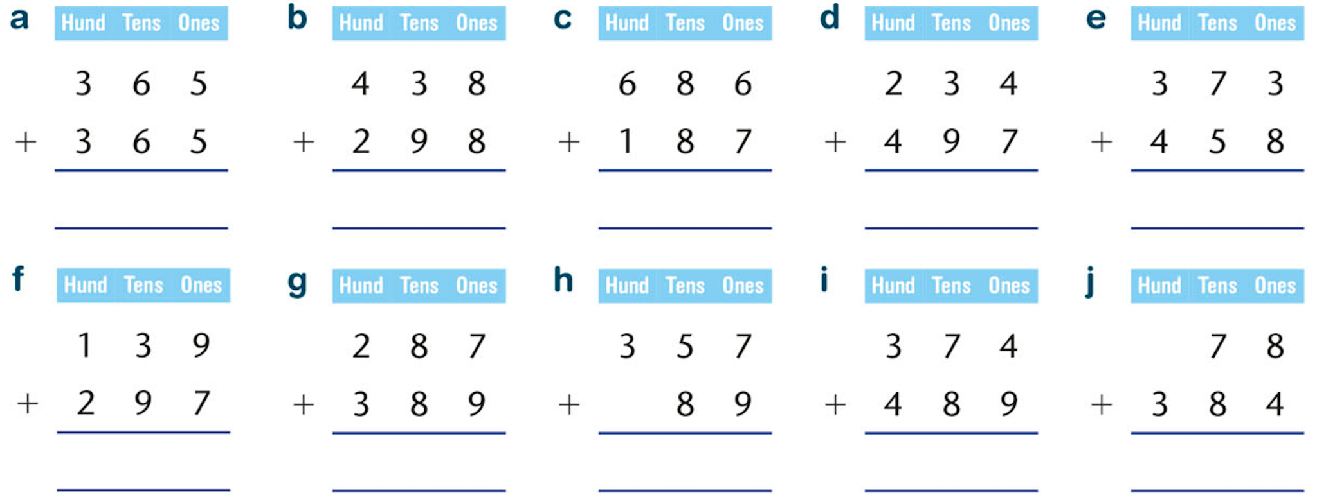

Activity 3: Calculate the cost of the following items.
