Wednesday - Maths - Week 3 - Year 3

WALT: Solve word problems by selecting the appropriate mental and written strategies.

Teaching Tips:

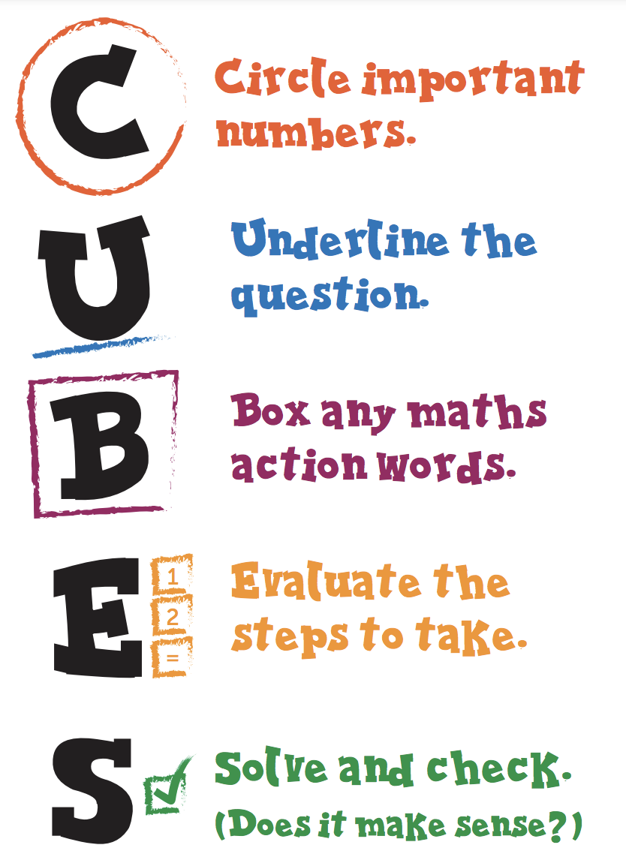
Activity: Use the CUBES strategy to evaluate the word problems and solve the questions in an efficient way.

- The school day starts at 8:20 am and ends at 3:05 pm. How long does the school day last? | - Kelly went to a movie that started at 4:45 pm. The movie went for 2 hours and 5 minutes. What time did the movie end?
- Melvin arrived at the shopping centre at 11:35 am. He had been on the bus for 50 minutes. What time did he get on the bus? | - Jess goes to bed at 8:15 pm each night. She wakes at 6:45 am. How long does Jess sleep for?
- 45 students are at a pizza party. 23 students want 2 pieces of pizza and the remaining students want 3 pieces. Each pizza has 8 pieces. How many pizzas should they order? | - Alex needs 3 kg of ham to make sandwiches for his soccer team. The ham comes in 1kg packets. How many packets does he need to buy?
- It is recommended that you drink 2 L of water every day. If your cup holds 500 ml, how many cups of water would you need to drink to have 2 L? | - On average, 4 babies are born every second world-wide. How many babies are born in a minute?

