Spelling Activities Week 2- Year 4
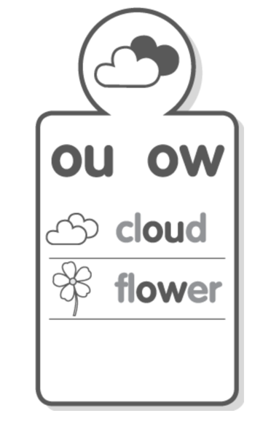
Sound Focus

www.soundwaveskids.com.au

Student Access Code: toss701
Fast finishers: play the online games

Friday:
- Complete the look-cover-write-check for Friday.
- Optional:
