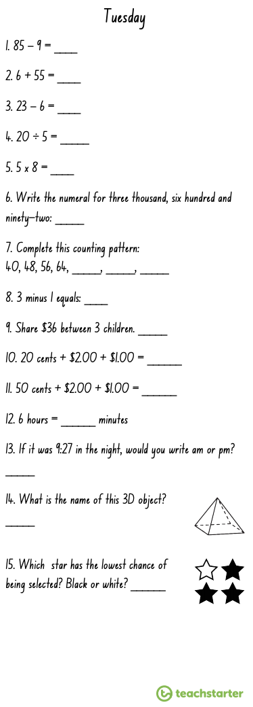
Multiplication Spirals
- Choose 5 spirals and use a timer to time yourself.
- Write your time above each spiral each day and try to beat that time the following day.
- You should choose the times table you are the least confident with to improve.

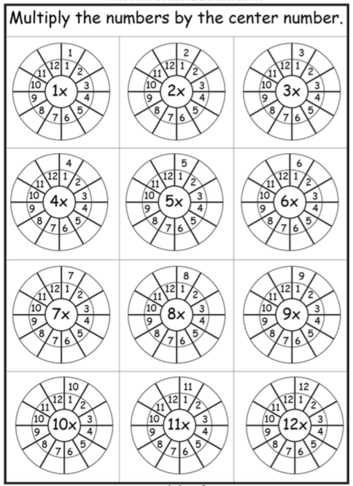

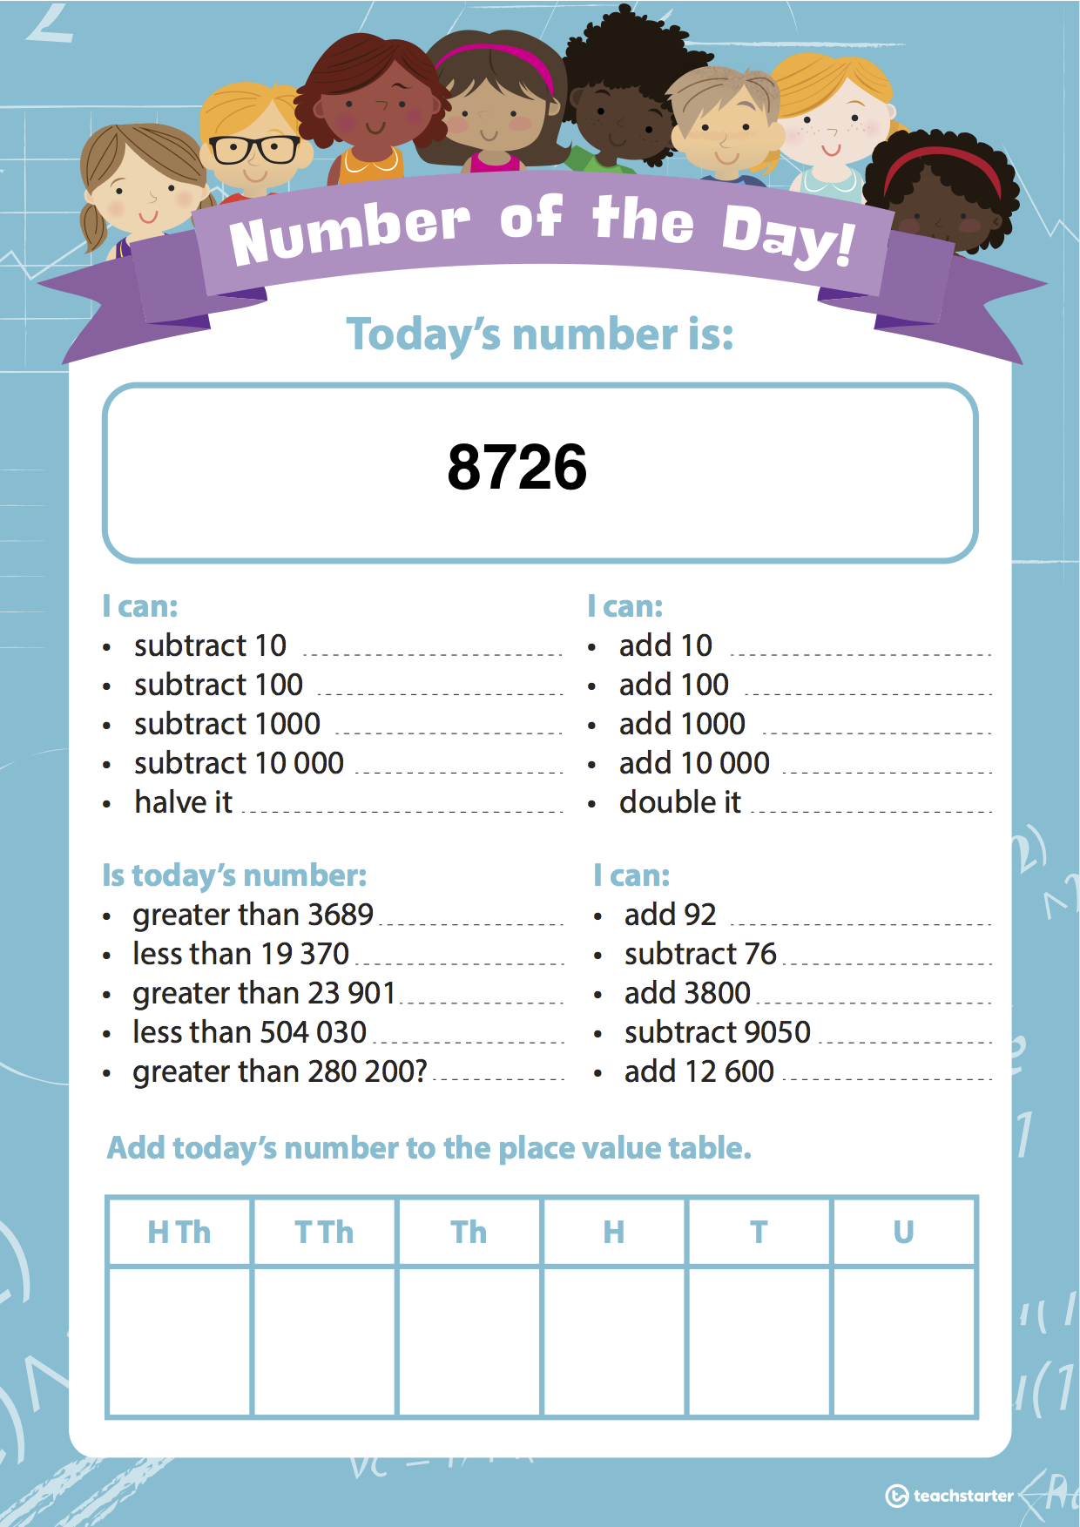
WALT: Extend fraction and decimal patterns using a rule.

Activity 1: Use the number line to complete the fraction pattern.

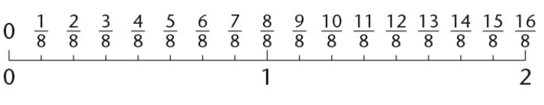
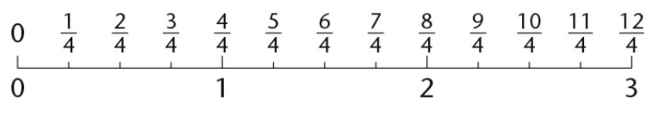
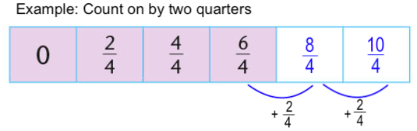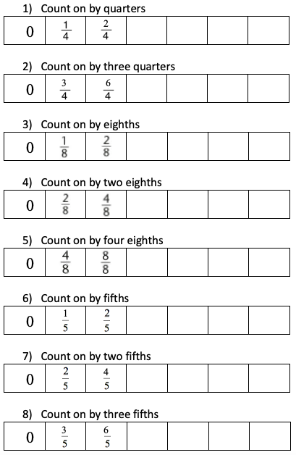

Activity 2: Complete the decimal pattern.

