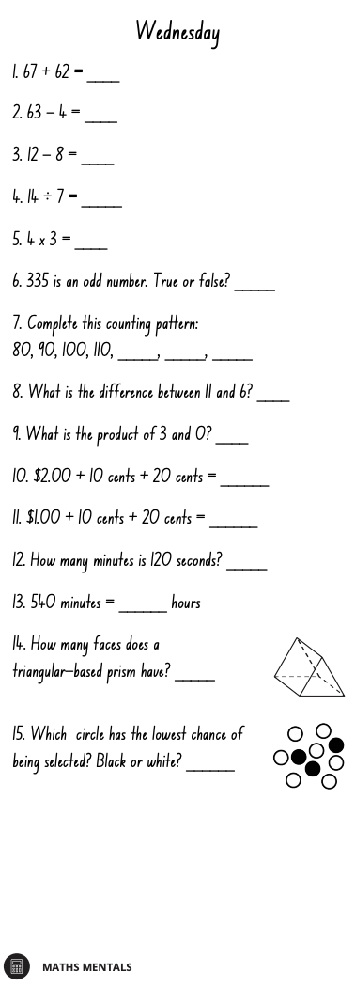
Multiplication Spirals
- Choose 5 spirals and use a timer to time yourself.
- Write your time above each spiral each day and try to beat that time the following day.
- You should choose the times table you are the least confident with to improve.

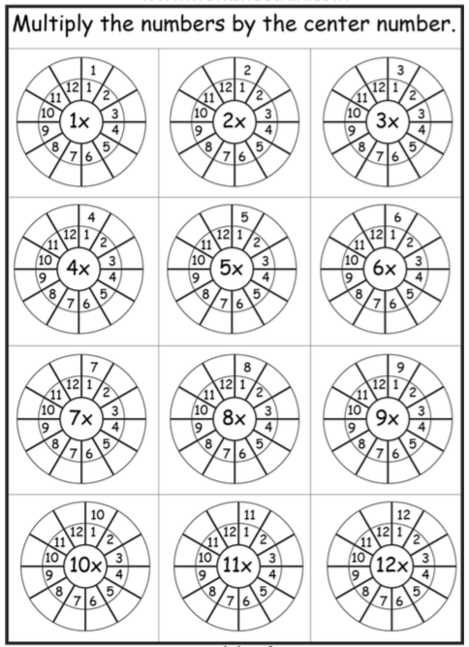

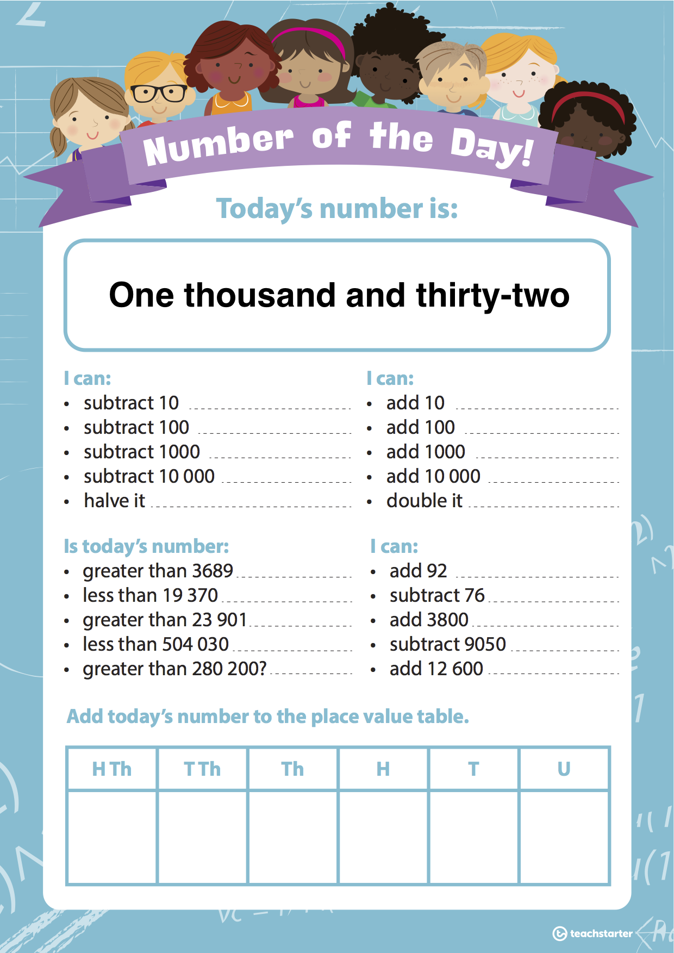
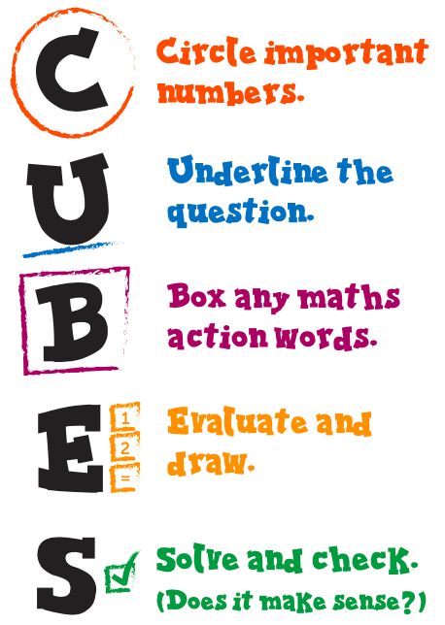
Word Problem Wednesday!

WALT: Solve word problems by working mathematically.

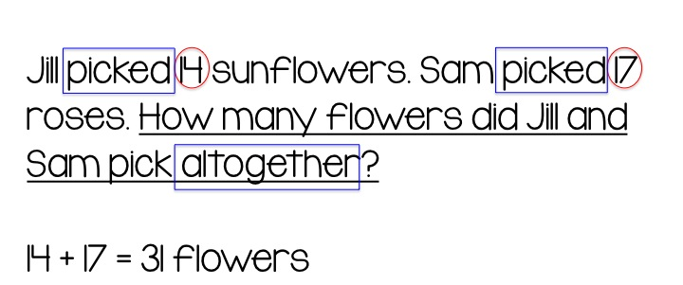
Activity 1: Use the CUBES method to solve the following word problems.

- Steven read 9 books each month. He read the same number of books each month for six months. How many books did Steven read in total?

- Noah and his dad are visiting an amusement park. The entry fee for Noah is $34.95. The entry fee for his dad is $41.95. How much change would they receive from $100?

- Sue chose a box of chocolates that had 6 rows of 3. Ben chose a box of chocolates that had 8 rows of 2. Who had more chocolates?

- There are 12 koi fish swimming in a pond. These fish make up ¼ of all the fish in the pond. How many fish are in the pond altogether?

- Mr. Smith has 28 children in his class. If he wants to give each child 2 sweets each, how many sweets does he need to buy?

- Each chicken coop can hold 8 chickens. What is the maximum number of chickens that can fit in 7 coops?

- Liam collected 36 football cards. Lisa collected ¾ of the amount Liam did. How many football cards did Lisa collect?

- A toy train weighs 35 grams. A toy truck weighs 127 grams. How much heavier is the truck than the train?

- Nathan’s basketball game started at 9:15 am. Nathan was running late and missed 23 minutes of the game. What time did Nathan arrive?

- Jack wanted to purchase three lollipops. Normally they are 35 cents each, but today they are on special and he can buy three for $1.00. How much money would Jack save by purchasing the special?

Activity 2: Create 5 word problems of your own using the different operations (+ - x ÷). Swap with a friend and have them complete your word problems using the CUBES method.

