WALT: Solve 5-digit addition using a formal written algorithm involving trading.

Example:
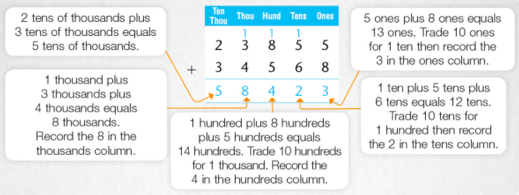

Activity 1: Complete the following 5-digit addition problems involving trading. Include all working out.
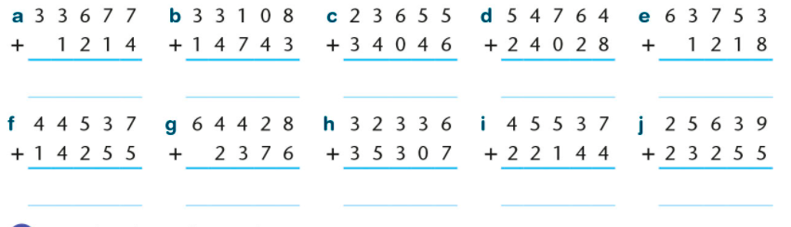

Activity 2: Robbie completed 4 addition sums. His teacher asked him to check his answer by completing the inverse operation (subtraction). He has done the first one, can you do the rest?
