Spelling Activities Week 3- Year 4

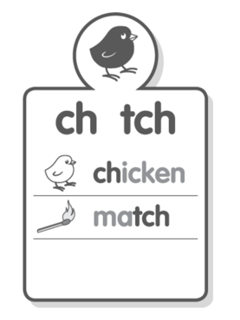
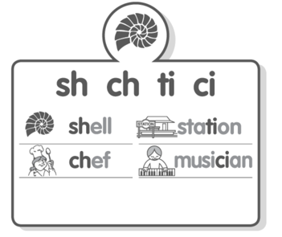
Sound Focus

www.soundwaveskids. com.au

Student Access Code: toss701
Fast finishers: play the online games

Monday:
1.Record your list words in your book.
2.Record the number of phonemes (sounds) for each word.
3.Brainstorm other words that contain the phoneme (sound).
4. Complete the look-cover-write-check for Monday.

